**Statistical machine translation (SMT)/ Alignment models.**

* Statistical machine translation (SMT) is a data-driven approach to machine translation that relies on statistical models to translate text from one language to another.
* Alignment models are a type of SMT model that learns how to align words or phrases between the source and target languages.
* This information is then used to improve the translation performance of the SMT system.
* Alignment models also have been shown to improve the performance of SMT systems by providing a more accurate alignment between the source and target languages.

There are two main types of alignment models:

|  |  |
| --- | --- |
| **Word-based alignment models** | **Phrase-based alignment models** |
| These models align words between the source and target languages. | These models align phrases between the source and target languages. |
| They are typically based on the “IBM Model 1” model | They are typically based on the “IBM Model 4” model |
| It is a generative model | It is a generative model |
| It learns how likely a word in the target language is based on a word in the source language. | It learns to segment the source language text into phrases and then aligns these phrases with phrases in the target language. |

## **Statistical Alignment Model:**

* A statistical alignment model is a type of machine learning model used in natural language processing (NLP) for aligning words or phrases between two sequences of text, typically in the context of machine translation (MT).
* These models are trained on a large corpus of parallel text, which consists of pairs of sentences or documents in two different languages.
* The model learns to identify the corresponding words or phrases in each language pair
* Later this information is then used to improve the accuracy of the MT system.

**Applications of statistical alignment models:**

|  |  |  |
| --- | --- | --- |
| **Machine translation (MT)** | **Morphological analysis** | **Part-of-speech tagging** |
| Statistical alignment models are used to identify the corresponding words or phrases in each language pair | Statistical alignment models can be used to identify the morphological structure of words, such as their stems and affixes. | Statistical alignment models can be used to assign parts of speech to words in a sentence. |
| This information is then used to produce the translation. | This information can be used to improve the accuracy of natural language processing tasks such as text summarization and information extraction. | This information can be used to improve the accuracy of natural language processing tasks such as machine translation and speech recognition. |

**EM algorithm:**

* Expectation-maximization (EM) is an iterative algorithm used to find the maximum likelihood estimates of parameters in statistical models. It is commonly used in machine learning, particularly in natural language processing (NLP) and statistical machine translation (SMT).
* In SMT, EM is used to train alignment models, which are used to identify the corresponding words or phrases between the source and target languages.
* It is also used to find the latent variables (variables that are not observed directly but are inferred)

**Steps involved in EM algorithm:**

* **Initially a set of initial values are considered.**
* **A set of incomplete data is given to the system**

**Expectation Step (E-Step):**

* The expectation step involves computing the expected value of the complete data log-likelihood under the current model parameters and the observed data.
* This involves calculating the expected values of the latent variables given the observed data and the current model parameters.
* In the context of alignment models, the hidden variables are the alignments between the words or phrases in the source and target languages.

**Maximization Step (M-Step)**

* The maximization step involves updating the model parameters to maximize the expected log-likelihood computed in the E-step.
* This involves solving an optimization problem to find the parameters that maximize the expected log-likelihood.
* In the context of alignment models, the parameters of the model are the probabilities of a word in the target language given a word in the source language.

**Iterations**

The EM algorithm iterates between the E-step and M-step until convergence is reached. Convergence is typically assessed by checking whether the change in the model parameters between two consecutive iterations is less than a specified threshold.

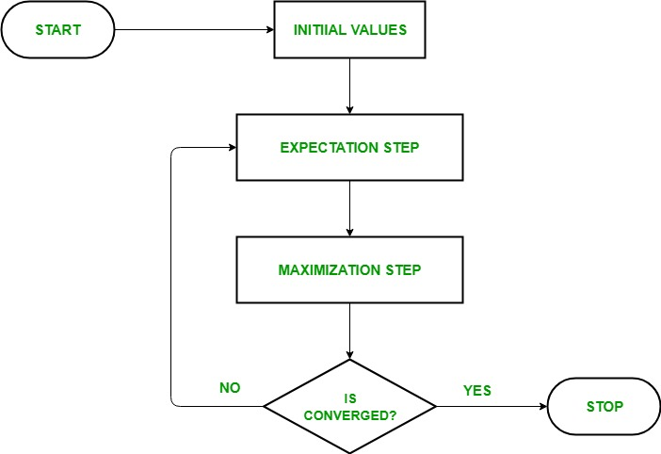

Basic issues in Machine Translation:

|  |  |
| --- | --- |
| **Word sense disambiguation** | Words often have multiple meanings, and MT systems often struggle to determine the correct meaning of a word in a given context. |
| **Grammatical issues** | MT systems often struggle with grammatical issues, such as subject-verb agreement and verb tense. |
| **Domain-specific knowledge** | MT systems often lack the domain-specific knowledge necessary to accurately translate texts in specialized fields, such as medicine or law |
| **Noise** | MT systems can be sensitive to noise in the training data. |
| **Data sparsity** | MT systems require large amounts of training data to be effective |

**Rule based techniques:**

* Rule-based techniques are a set of methods used in artificial intelligence (AI) to represent and process knowledge in the form of rules.
* Rules are typically expressed in the form of if-then statements, where the if-part describes a set of conditions and the then-part describes a set of actions to be taken if those conditions are met.
* Rule-based techniques are often used in expert systems, which are computer programs that are designed to emulate the decision-making process of a human expert.
* Expert systems typically use a knowledge base that contains a collection of rules about a particular domain.
* The system then uses an inference engine to apply those rules to new data in order to make decisions or provide recommendations.

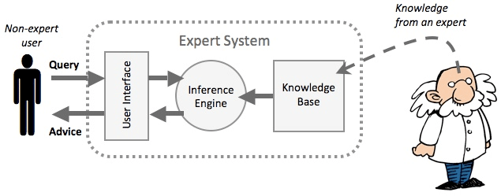

|  |  |  |
| --- | --- | --- |
| ****Word alignment**** | ****Phrase-based translation**** | ****Synchronous grammars**** |
| A statistical method that learns how to align words or phrases between a source language and a target language. | A statistical method that breaks up the source language text into phrases and then translates each phrase independently. | A formal method that provides a set of rules for generating pairs of sentences or phrases in a source language and their corresponding translations in a target language. |
| Is one of the most basic methods used in statistical MT. | Is often more accurate than word-based alignment, but it can be more difficult to implement. | Is often the most accurate approach to MT, but it can be the most difficult to develop. |
| Is typically based on the IBM Model 1 or the HMM model. | Is based on a statistical model that learns the probability of a phrase in the target language given a phrase in the source language. | Are based on a set of rules that define the relationship between the source language and the target language. |
| Is a relatively simple method, but it can be very effective in improving the accuracy of MT systems. | Can be used to translate a wide range of languages. | Can be used to translate a wide range of languages and can achieve very high levels of accuracy. |
| Is a good choice for MT tasks where the source and target languages are closely related. | Can be more difficult to implement for tasks where the source and target languages are not closely related. | Can be difficult to develop, as the rules must be carefully crafted to capture the relationship between the source and target languages. |